Development of a Portable Electroluminescence Measurement System for Photovoltaic Modules

*Andrew Leong, Balaji Radhakrishnan, Bhargav Ashok, Lihui Zhang, Yixin Lu, and Zhengdao Zhou*

Australian National University, Canberra, Australia

*Abstract*—The use of solar panels is growing as the world moves towards a greener future. However, there are existing technologies that create equity issues due to the high-cost barrier to entry. One example is the electroluminescence testing of solar panels that is an effective and accurate method of identifying errors in solar panels through infrared light. Current methods of electroluminescence imaging are costly and therefore inaccessible to a wide range of solar panel owners, such as rural villages that rely on solar powered microgrids to power their day-to-day needs. The goal of this project was to design and develop a portable electroluminescence measurement device that utilizes cheaper and more available components. The main novelty of this project is the image processing algorithm used to eliminate external lighting noise. The developed system is a portable electroluminescence device that uses a portable computing system, high quality camera, and portable power source with an attached current regulator. The developed system can image one solar panel at a time and produce accurate electroluminescence images within 5 minutes.

Keywords—Electroluminescence, solar panel testing, image processing, current regulation, development, iterated prototype, Raspberry Pi.

# Introduction

Electroluminescence (EL) imaging is a test that is widely used to identify inactive and/or defective cells in solar panels [1]. This method uses the phenomenon of luminescence, where an object is able to emit light without being heated. The concept of electroluminescence follows a similar principle but arises due to the passage of an electrical current through a material. This introduces the possibility of using electroluminescence on a solar panel due to the reciprocity rule [1]. A solar panel normally operates by absorbing light and producing an electrical current, but due to reciprocity, an electrical current can instead be run through a solar panel which in turn produces light. The photoemissions released by the panel are in the infrared range and therefore cannot be seen with the naked eye, making the use of an infrared camera necessary to capture an EL image of the panel. The solar cells in the EL image will appear as white due to the photoemissions, allowing dark areas of the cell to highlight the location and type of issue within the panel, such as microcracks, inactive areas, and fabrication errors.

The current method of EL imaging follows two main methodologies [1]. The first method is conducted in an indoor lab that consists of a dedicated EL room that is able to satisfy the optimal conditions for EL imaging. The key conditions include the use of an appropriate camera, ambient temperature, and environmental lighting. An appropriate camera is one that has a high resolution, high sensitivity to light, and suitable spectral band, and are typically very expensive. Due to the highly sensitive camera, low environmental lighting conditions are required and an ambient temperature of 20°C to 25°C is optimal for solar panel performance. Although this method of testing produces the most accurate results, it also costs the most due to its complexity and costly components. The second method, which is the focus of this report, conducts the EL imaging in-situ using a portable EL measurement device. This has several benefits over the lab test as it can be performed faster and does not require the panel to be dismantled from its support structure. This means that the panel is not deactivated for long periods of time and can still produce energy. To obtain reliable results using the portable system however, low lighting conditions are still required. This means that tests are performed either at night or utilise a cover to block out external light.

The main issue with the current methods of EL testing is not one of a technical nature but of a financial nature. The high-cost barrier gatekeeps any party that is not a large-scale solar farm from reliably testing their solar panels. This can include residential solar panel owners who simply wish to identify why their panels are producing less power than expected and student/personal projects who wish to ensure the optimal performance of a solar panel being used in development. Furthermore, some of these parties are disadvantaged communities that require the optimal performance of their solar panels to provide them access to electricity. Examples include rural villages disconnected from the main power grid whose sole electricity source is a solar powered microgrid. Therefore, the main purpose of this project is to develop an open-source portable EL measurement device that is more accessible by utilising less costly components.

# Problem Definition

The EL system to be designed will be a portable system that can image one solar panel at a time. As the intended design is a portable system, there is no guarantee that the external noise from the ambient temperature and light can be removed all the time. Therefore, the system will have to account for these factors to produce an accurate estimation. The method to account for the external noise will involve capturing a sequence of infrared images when current is run through the panel (bright state) and when no current is sent to the panel (dark state) as seen below in *Fig. 1*. The bright and dark images will then be minus from each other to remove the noise, theoretically leaving only the photoemissions from the panel left. Furthermore, multiple pairs of images will be captured and averaged to remove more noise and obtain an accurate result.

To be able to achieve this, the system will need to be controllable. The two main components to be controlled are the camera to properly time when images are captured and the current regulator to time when current is sent to the panels. Furthermore, the current regulator needs to be able to alter the current to meet the rating of different types of solar panels. This means that a control algorithm needs to be developed on a portable computing system and the circuitry of the current regulator needs to be designed to handle a wide range of current from a single power source.

The expected outcome of the project is a portable system which means that it should be transportable by a single person, operate long enough and in any environment (lighting and terrain), for a reasonable application of the device. Furthermore, the system should be able to obtain clear EL images within a reasonable time. As one of the key values of this project is accessibility, the system should not have a high cost while utilising easily obtainable components. The benchmarkable requirements of the system and its evaluation can be found in the *Appendix A.*

# Technical background

Based on the problem definition, it is clear that the project requires knowledge and skills in both programming and electro-mechanical skills. Like every other project, there also needs to be a management team that handles all the stakeholder interactions as well as the interlinking the different subsystem teams. The team first created a brief block diagram of the different subsystems, based on the requirements of the client, as shown below in *Fig. 2.*

Based on this approach developed by the group members, the team was split into two technical teams and one management team. The technical teams were classified as software team and the hardware team. The main tasks of the software team were to handle the graphical user interface as well as the algorithm development of the illustration modulation technique. The hardware team was focused on creating a current regulator device that could safely pass current to the solar panel.

## Software Background

The software aspect of the project can be divided into two further subsystems, the graphical user interface (GUI), and the image capture and processing algorithm.

For the GUI, Tkinter was selected as the toolkit for design. It is a GUI package developed for the Python programming language. Tkinter is a cross-platform GUI toolkit that can be accessed from multiple operating systems, including Linux, Microsoft Windows, and Mac OS X installs of Python. Furthermore, Tkinter provides a powerful object-oriented interface to the Tk GUI toolkit and was selected as it is the most commonly used module for building GUI applications in Python due to its simplicity and availability. Tkinter makes it very easy to create windows, buttons, menus, text boxes, labels, and many other widgets.

For the image capture and processing algorithm, the portable computing system used in this design is a Raspberry Pi and its PiCamera module, the Python programming language, and several Python libraries such as “picamera”, OpenCV, and NumPy, alongside GPIO interfacing. The Raspberry Pi is a versatile, low-cost single-board computer, and PiCamera is its dedicated camera module. Python, a high-level language known for its simplicity and wide-ranging capabilities, is used here to script the entire process. The “picamera” library offers a pure Python interface to control the PiCamera. OpenCV, an open-source library rich in computer vision algorithms, is utilised for image transformation, the image difference calculation to remove noise, and most importantly, image saving. NumPy, a powerful library for numerical operations, is used for efficient array manipulations, critical in the image processing tasks. Lastly, the script uses the GPIO pins of Raspberry Pi to control external devices, showcasing the Raspberry Pi's ability to interact with the physical world. A general-purpose input/output (GPIO) is a controllable pin on the Raspberry Pi that is used as an input, output or both [2]. This script illustrates an integrated application of hardware control, image processing, and computer vision using the Raspberry Pi and Python's robust ecosystem.

## Hardware Background

The hardware part of the system is comprised of two subsystems, a current regulator, and a radio frequency (RF) communication link. The current regulator and RF link is built based on power circuit knowledge.

The main goal of the current regulator is to modulate the amount of current that flows into the solar panel from a power supply. As the system needs to be portable, the power supply of choice is a 50V e-bike battery with a current rating of 35A, giving it a total power rating of 1.8kW.

In general, the average operating current rating of a solar panel is typically between 8A to 10A with power rating of approximately 300W to 400W [3]. As such, if the power source is directly connected to the solar panels, it will destroy the solar panels and cause serious heating issues due to the power rating difference. Hence to balance the system and safely pass current through the solar panels, the current regulator must lower the voltage from 50V to 5V to operate the circuit components and maintain the current at 10A to produce an EL image.

To achieve this, potential Commercial Off the Shelf (COTS) devices that can handle the voltage and current from the power source were first researched and identified. The operating temperature of the component was also assessed. Additionally, the team was supported by a technical consultant who helped provide domain expertise that the team initially lacked. To help design the circuit and validate the components before procurement, the LTspice software was used to simulate the design. The initial circuit design was obtained from the component datasheet manual as seen in *Appendix B* [4]. Using the results of LTspice, the team was able to identify the total number of resistors, capacitors, inductors, and diodes along with the component sizes required to build the circuit. The individual components were procured from various sources including the client. To build the circuit, the team used the ANU Makerspace equipment and advice from the technical expert. Furthermore, the team used its prior experience and knowledge from mechanical engineering to make the circuit into a product for the client.

In terms of the communication between the Raspberry Pi controller and the current regulator circuit, an RF module was integrated into the system. The RF module has two components, a transmitter, and a receiver. The transmitter circuit can transfer an input signal to radio wave and send that out through an antenna. Then the receiver can intercept that radio wave through another antenna, and convert the radio wave to an output signal, which is ideally same as the input signal of transmitter. The RF module implemented in this project is the Linx LR-433 RF module [5], which is designed to send and receive radio waves with 433.92MHz frequency. The transmitter board is attached to, and powered, by the Raspberry Pi controller. Furthermore, the Raspberry Pi is designed to send a periodic step signal through the GPIO function, as the indicator for triggering current regulator (i.e., send logic-high signal to switch on the current supply to solar panel, vice versa). The receiver board is attached to the current regulator circuit. It is powered by two AAA batteries for the purpose of reducing circuit complexity. It is designed to output either logic-high (3.3V) or logic-low (0V) signal, for the purpose of switching the current supply on and off.

# Solution developed

The designed solution shown in *Fig. 2* is detailed in this section. The description of the solution developed, and the techniques used with justification are explained such that it can be recreated by another team.

## Software Subsystem

As a portable system that is embedded in the Raspberry Pi, the user must easily operate and execute the algorithm through the GUI on a 7-inch Raspberry Pi touch screen display. The GUI was designed to show the title of the software and present the user inputs such as operation mode selection (auto or manual), live camera testing, number of desired image pairs, camera light sensitivity (ISO), and resolution. The live camera testing enables the user to check if the camera is facing the desired location and if it is in focus, after which the “Start Testing” button will start the image capture and process algorithm with the user defined settings.

The image capture and processing algorithm runs autonomously on a Raspberry Pi with a Pi Camera attached, capturing a sequence of images, computing the difference between consecutive pairs, and averaging these differences to generate the final output, the EL image. The function "capture_and_diff" is responsible for capturing images and calculating their differences. It takes parameters such as shutter speed, the number of photos to capture, wait time between photos, photo resolution, and camera ISO setting. Using the Raspberry Pi GPIO library, GPIO pins are set up to control the camera's power. The PiCamera object is initialized with specific parameters including ISO, sensor mode, resolution, framerate, and raw format. After a 2-second delay for automatic gain control to settle, the script sets the camera's shutter speed and white balance. Next, the algorithm enters a loop where it captures the specified number of images. Once all images have been captured and their differences computed, the average difference image is calculated by dividing the difference accumulator by the number of photos. This average difference image is saved as "average_diff_image.png" on disk.

Overall, the algorithm is designed to compare images taken with different powering conditions, specifically for evaluating the impact of electroluminescence on photovoltaic modules and find their defects.

## Hardware Subsystem

A requirement of the system was that the maximum allowable current to pass through the solar panel should be 10A. This was based on the and power requirement of a typical solar panel. To make the subsystem compatible, operable and cost-effective the current regulator device was developed from scratch. The team identified the HV9910C chipset, which is normally a LED driver chip, as the key component of the current regulator. The reason why the HV9910C chipset was chosen was mainly due to its availability, low cost, and its ability to handle the required rating of 50V. Furthermore, the temperature threshold of the chip is approximately 120°C, making it appropriate for this design. The first step to satisfy the requirement was to use LTspice to simulate the circuit as seen in *Fig. 3.* During the design phase, various iterations were created by running tests on LTspice. The component sizes were altered to identify to best way to satisfy the system requirement. The model was successfully simulated in LTspice with the results shown in *Fig. 4*.

It was observed from the simulation that 3A current is drawn from the power source while approximately 10A of current flowed to the solar panels. Additionally, the necessary components were procured online from Element14, with some component obtained by recycling old used circuits from computers. The components were procured with the idea of building the circuit on a copper clad board instead of a prototyping board, because longer wires would increase the inductance and thereby the ripple current. This would cause overheating issues in the circuit.

From *Fig. 3* it is observed that the chipset requires support of resistors, capacitors, inductors and diodes to manage the ripple current and voltage in the circuit. Thereby the power flowing in the circuit can be controlled and heating issues can be mitigated. The rating/size and description of each component used in the final prototype is provided in *Appendix C*. The rationale for selecting certain key components is detailed below in *Table 1.*

*Table 1: Decision rational and validation behind choosing certain key components for the circuit*.

|  |  |  |
| --- | --- | --- |
| Part | Decision | Support |
| HV9910C | The chip handles the current and voltage from the power source | Designed in LT spice, Validated by results |
| Resistor | To reduce the voltage where necessary, so that components can be integrated safely | The chip, potentiometer and switch operate at a lower voltage compared to the high voltage power supply |
| Capacitor | To use capacitor to help reduce current amplitude, and reduces current spikes when current starts flowing | Validated by LT spice results |
| Diode | Alternative load to help current flow through the circuit, and absorb some of the power from the power source | Validated by HV9910C Datasheet |
| Switch | To break circuit when not in use or complete circuit when in use | Needed for RF link connection to control circuit from GUI |
| MOSFET | To help current pass from the chip to the solar panels safely | Validated by HV9910C Datasheet |
| Inductor | To reduce ripple current in the circuit, so that current flows at 10A | Validated by LT spice results |

This approach was a roadmap into creating and finalizing the current regulator components. The final step was to physically connect the components. While building the prototype, the team consulted the technical expert for advice on components placement. The MOSFET, diode, capacitor, and inductor were connected off the copper clad board and placed on an aluminum heat sink, to help reduce the temperature rise in the circuit. The rest of the components were connected on the copper clad board. The only external components are the power source and solar panel connections along with the potentiometer, current meter, and switch. The final design of the circuit and prototype can be seen in *Fig 5* and *Appendix F* respectively.

The RF communication link was then added to the circuit by providing connection point on the circuit to the chip. The receiving voltage was 3V, which operated like a switch, with current passing through the circuit only when 3V was received from RF communication link.

As shown in *Fig. 6.,* the connection is made in pairs, where the transmitter is attached to Raspberry Pi and receiver is attached to the current regular’s MOSFET chip. The port GPIO 7 on the Raspberry Pi was used to generate the triggering step signal. In specific, the GPIO port sends out X+0.1 seconds-long logic-high signal and X+0.1 seconds-long logic-low signal in sequence, where X is a user input that determines the responding period for the current regulator (5 seconds). In that case, as described above, the RF receiver will output a 3V-peak step signal at the same frequency, to switch on/off the current supply to solar panel. The connection between each component is made with Dupont wires soldering.

# Solution evaluation

For the image capture and processing algorithm, functional tests and performance tests were run. The functional tests involved executing the entire script and checking if the resulting images were as expected. This was done manually by inspecting the images and automatically by comparing the output images to a set of expected images using a metric such as the structural similarity (SSIM) index. Performance tests involved measuring the time it took to execute the script and the memory it used. The script was then run with different inputs (number of photos, wait time, resolution, ISO) and the effects on performance was observed.

For the GUI, based on the successful design of the image processing, the user will be able to use the GUI to control the parameters of the system. User testing was performed to observe the intuitiveness of the GUI and how users would control the operation mode and change the user input.

To evaluate the current regulator circuit, the team used light bulbs to simulate passing current through a load as shown in *Appendix D*. The light bulbs were rated 3.3A. By combining 3 lights bulbs, a similar scenario as a solar panel was created with a current rating of 9.9A and power rating of around 50W. The result of this test showed that the current regulator was able regulate the current sent through a solar panel by using a potentiometer. The brightness of the bulb would increase as more current was sent through and vice versa. However, it was noticed that the circuit was heating up significantly and almost reaching 120°C. The reason was because the type of resistor attached at channel 2 of the chip had a higher inductance than expected. Hence to solve the issue the resistor was replaced with a surface mount resistor, that had a lower inductance. The circuit was tested again and had no heating issues.

The RF communication receiver was tested using a 3V battery. A voltage to the RF receiver was supplied which completed the circuit, thereby passing current when a signal was received. the battery operated in a similar way to the RF link receiver. Moreover, an additional testing experiment using Raspberry Pi and Arduino to power the RF module is performed. It is validated that power supply and the signal transmission works as designed.

Once the individual components were successfully tested, the team started working on integrating the components together. The Raspberry pi along with the camera was connected to the RF trigger. The RF receiver was connected to the current regulator, which was then connected to the power source and the panel. The entire system was tested by using a 4-cell solar panel that had a current rating of 8A. The testing configuration can be seen in *Appendix E*

Finally, the developed solution was evaluated against the requirements of the system in the form of technical performance metrics. The evaluation is detailed in *Appendix A* and shows that the system satisfies a majority of the requirements. The waterproof, windproof, and scratchproof criteria are not applicable as the system is still in the prototyping phase and will only be evaluated the final system has been developed. Furthermore, the only criteria that the system performs poorly on is the amount of external lighting noise the system can operate with. This issue can be resolved by implementing a light filter with a better camera and by altering the camera exposure time in the next prototype.

# Results

*Fig. 7* below shows the final design of the GUI for this project. All functions described in the previous section are embedded. User testing showed that the interface was straightforward and easy to use, however, further testing is required to expand the sample size and gather more diverse feedback.

To test the algorithm, the code was run, and it successfully utilized the Raspberry Pi Camera to capture images under different power conditions, and then computed the difference between these images. The resulting EL images, shown in *Fig. 8* were found to be highly effective in highlighting defects in photovoltaic modules. The defects are clearly visible as the areas with a significant difference in electroluminescence, allowing for easy identification and further investigation. Some key features of the results are explained below.

**Defect Detection Accuracy**: The project performed exceptionally well in terms of detecting defects in photovoltaic modules. The method employed allowed for a high degree of accuracy in distinguishing between normal and defective areas. This indicates that the code performs well in the primary performance criterion for this application.

**Image Quality**: The quality of images captured and the difference images generated were high, allowing for easy visualization and interpretation of results. This suggests that the camera settings were appropriately configured for this specific application.

**Usability**: The code provided options for manual and automatic modes, allowing for flexible use depending on the user's needs. This enhances the usability of the tool in different scenarios.

The electrical team was able to create the device and safely pass up to 10A of current into the system. The current regulator prototype was placed into an ABS box with holes drilled for adding the potentiometer, current meter, switch and the contact points for the battery and the solar panel. The image of the final current regulator prototype can be seen in *Appendix F.*

The system with the integrated hardware and software components were integrated and tested, using different sized of solar panels. One such test results can be seen in *Fig 8*. The final result is an electroluminescence image of a solar cell that identifies the damages/ disconnected fingers. These damages/disconnections are observed as dark spots/black spots in the final image since no current passes through them.

# Conclusion and Future works

This project serves as a valuable proof of concept with two functional iterated prototypes that demonstrates the effectiveness of using image processing techniques for electroluminescence analysis in photovoltaic modules. The final prototype developed in this project utilises a Raspberry Pi Camera and an in-house image processing algorithm to evaluate the defects of photovoltaic modules by using electroluminescence. The image processing methodology employed produces clear results, detecting the defects in photovoltaic modules with a high degree of accuracy even with variations caused by different power and external conditions.

As such, the prototype demonstrates robustness and reliability by delivering consistently accurate results with the use of a user-friendly design. The system is designed for both technical and non-technical users through the implementation of different modes, automatic or manual, that allows technical experts to specify how they wish to test their panels, and also allows non-technical users to perform a basic test on their panel.

Future work should focus on enhancing image capture and processing. Primarily, transitioning from 8-bit to 12-bit image capture can improve dynamic range and reveal subtler electroluminescence differences. This may necessitate comprehensive research to determine an optimal approach for 12-bit capture, possibly involving a different camera module. Improving image quality is another vital area. This can be achieved through refining camera settings such as ISO, exposure, and white balance. Incorporating higher resolution sensors, superior lenses, and post-capture image processing techniques like noise reduction and contrast enhancement can also augment image quality. Lastly, allowing for longer exposure times could assist in identifying subtle electroluminescence effects, particularly in low-light conditions. However, potential increases in image noise associated with longer exposure times need to be accounted for. Implementing these enhancements can significantly broaden the project's scope and utility, potentially enabling more accurate and detailed analysis of photovoltaic module performance and defects.

Moreover, the project can be furtherly developed with the integration of printed circuit board (PCB) technology. As the current prototype in this stage is made by hand-soldering, PCB designing is able to increase the reliability and portability of the product. Also, it enables the reproductivity of the system and the cost can be further reduced.

##### Acknowledgment

We would like to thank our supervisors Dr Marco Ernst and Dr Hieu Nguyen as well as our technical consultant Mr Christopher Jones for their technical guidance and financial support throughout the whole development process of this project. Their expertise in the field has helped us tremendously and their patience with our learning process is greatly appreciated. We know we would not have been able to achieve this without their advice and understanding.

# References

|  |  |
| --- | --- |
| [1] | U. Jahn, M. Herz, M. Kontges, D. Parlevliet, M. Paggi, I. Tsanakas, J. S. Stein, K. A. Berger, S. Ranta, R. H. French, M. Richter and T. Tanahashi, "Review on Infrared and Electroluminescence Imaging for PV Field Applications," IEA PVPS, 2018. |
| [2] | Raspberry Pi (Trading) Ltd, “Raspberry Pi 4 Model B Datasheet,” Raspberry Pi (Trading) Ltd, 2019. |
| [3] | Sunpower, "Sunpower MAXEON 2 data sheet," [Online]. Available: https://sunpower.maxeon.com/au/sites/default/files/2022-09/Datasheet%20SPR-MAX2-xxx%20-%20Rev%20C.pdf. |
| [4] | Microchip, "HV9910C Data sheet," [Online]. Available: https://ww1.microchip.com/downloads/en/DeviceDoc/20005323A.pdf. |
| [5] | Linx Technology, “LR Series Basic Evaluation Kit User's Guide,” Linx Technology , 2015. |

##### Appendix A



*DoI = Direction of Interest

*Fig. A1. System Evaluation against Technical Performance Metrics for each system requirement*.

##### Appendix B

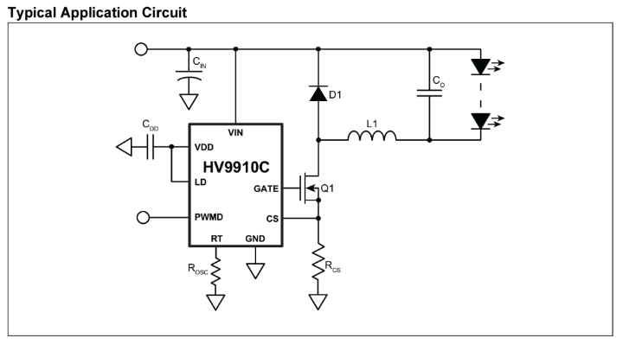

*Fig B1. HV9910C data sheet circuit layout.*

##### Appendix C

*Table C.1: Detailed description and rating of all components in current regulator circuit.*

|  |  |  |
| --- | --- | --- |
| Part | Description | Rating |
| HV9910C | The main chip that acts as the regulator. | 15V-450V, max temp of 125C |
| Resistor R1 | Resistor that connects to pin 8 of the chip (RT) | 240 k |
| Resistor R2 | Resistor that is used to step down the voltage to 5V | 18 k |
| R3 (potentiometer) | Help adjust the amount of current required. | 1k |
| Resistor R4 | Connected to the potentiometer | 18k |
| Resistor R5 |  | 17k |
| Resistor R6 | A surface mount style resistor | 50m |
| Resistor R7 | A surface mount styled resistor | 50m |
| Capacitor C1 | Connects to pin 6 of the chip (VDD) | 1 |
| Capacitor C2 | Connects to pin 7 (LD) of the chip | 0.1 |
| Capacitor C3 |  | 330 , 63V |
| Capacitor C4 | Connects to pin 1 (Vin) of the chip | 0.1 |
| Capacitor C5 | Added before current enters the panel | 1 |
| Zener diode |  | - |
| Switch | Normal 5V switch to activate the circuit | - |
| MOSFET | Used to connect the chip to the circuit and panel | 100V, 45A rating |
| Diode D2 | Schottky styled rectifier | 100V, 20A |
| Inductor L1 | Toroidal styled inductor | 380 |

##### Appendix D

*Fig D.1: Current regulator testing using light bulbs*.

##### Appendix E

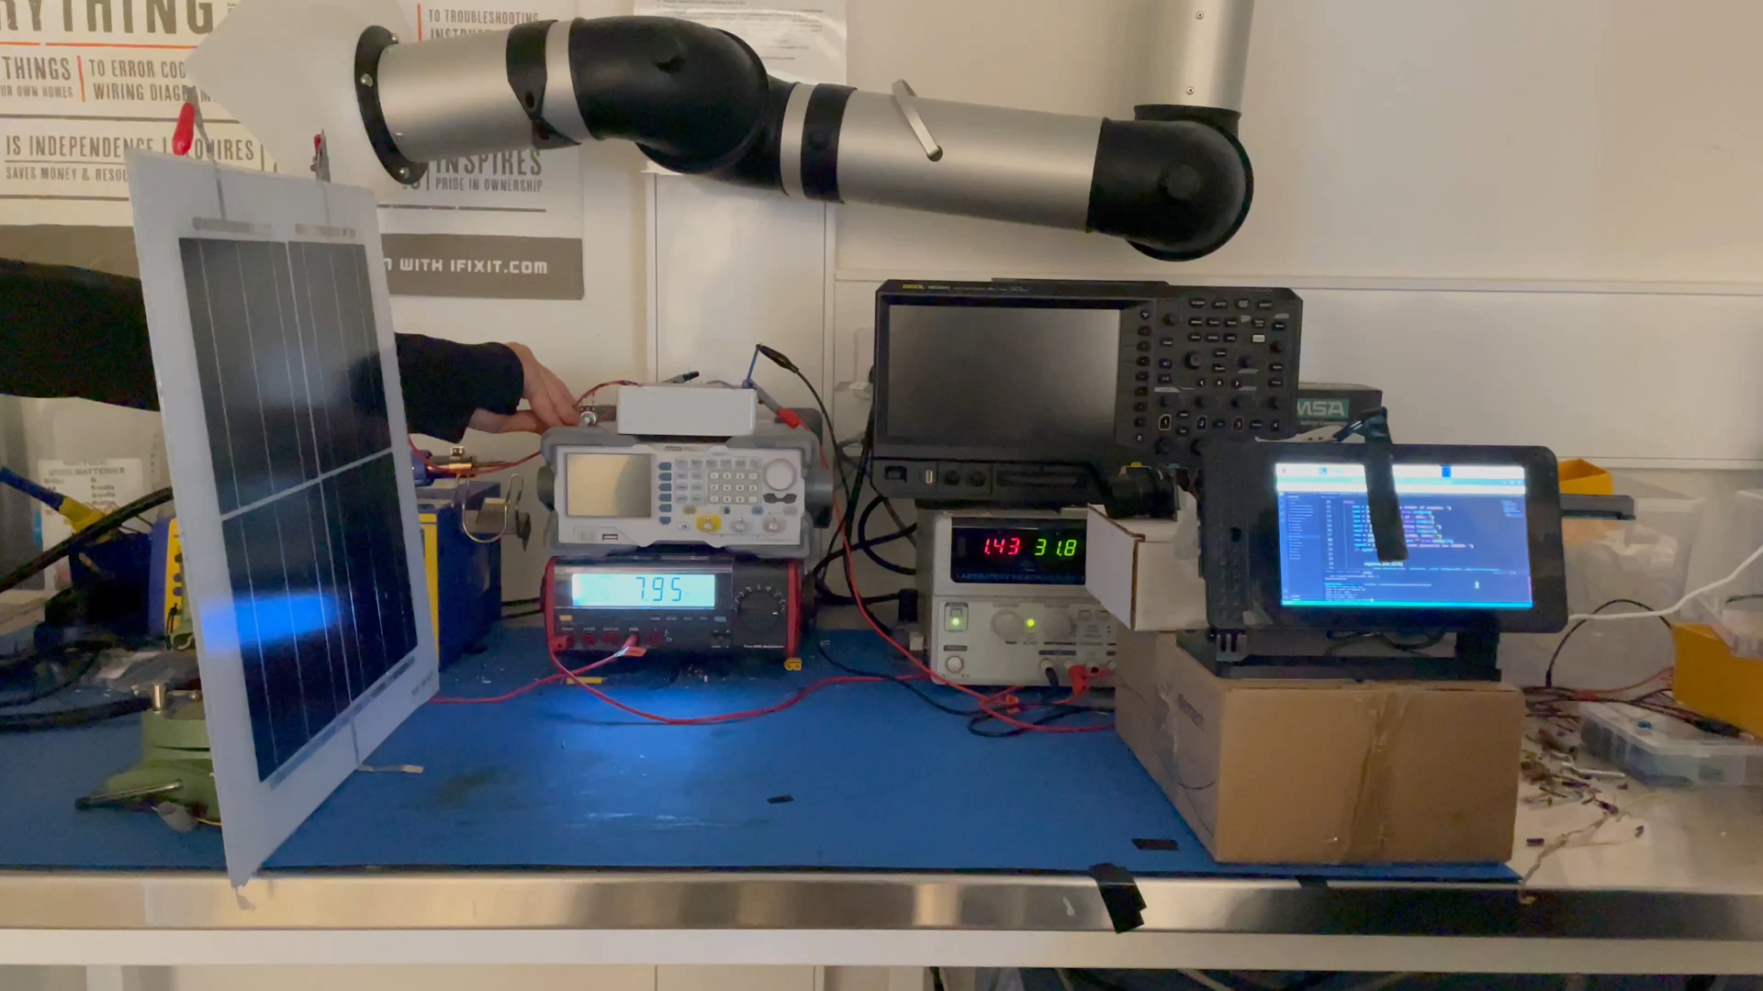

*Fig E.1: Integrated testing configuration*

##### Appendix F

*Fig F.1: Final current regulator prototype (top view)*

*Fig F.2: Final current regulator prototype (front view)*

*Fig F.3: Final current regulator prototype (side view)*